

**Contents**

1. **22 Intentions for the Year**

This template includes 22 intentions for your life this year. Check back regularly through the year to fill the template in, as having a visual representation of your progress will inspire and motivate you. If you choose, the template can be adapted with your own personalized intentions, or to add more boxes. The sky is the limit!

1. **Everyday Upgrade**

This template allows you to track your activities on given days to ensure you are living your happiest life. Use it to implement new habits or to reinstate positive activities when you are feeling down. The Everyday Upgrade checklist can also be personalised, and a blank template has been provided for this purpose.

1. **Thank You Universe**

Thanking the universe in advance is a confirmation that you trust that you are being guided and supported. Living in a space of gratitude and positive expectation will help you to manifest your wildest dreams and will also bring small, everyday gifts and help with the everyday challenges.

1. **Ideal Life Journaling**

Use these prompts to create, on paper, your ideal life. Manifesting is easier when the universe knows your dreams and desires. Also, clarifying them in your own mind will inspire you to take steps towards them.

**23 Intentions**

5 Things to Manifest

|  |  |  |  |  |
| --- | --- | --- | --- | --- |
|  |  |  |  |  |

5 Fun Things to Do

|  |  |  |  |  |
| --- | --- | --- | --- | --- |
|  |  |  |  |  |

5 Books to Read

|  |  |  |  |  |
| --- | --- | --- | --- | --- |
|  |  |  |  |  |

5 Things to Learn About

|  |  |  |  |  |
| --- | --- | --- | --- | --- |
|  |  |  |  |  |

5 Habits for Health

|  |  |  |  |  |
| --- | --- | --- | --- | --- |
|  |  |  |  |  |

5 People to Prioritize

|  |  |  |  |  |
| --- | --- | --- | --- | --- |
|  |  |  |  |  |

5 Things to Declutter

|  |  |  |  |  |
| --- | --- | --- | --- | --- |
|  |  |  |  |  |

5 New Foods to Try

|  |  |  |  |  |
| --- | --- | --- | --- | --- |
|  |  |  |  |  |

5 New Recipes to Cook

|  |  |  |  |  |
| --- | --- | --- | --- | --- |
|  |  |  |  |  |

5 Things to Buy

|  |  |  |  |  |
| --- | --- | --- | --- | --- |
|  |  |  |  |  |

5 Projects to Start

|  |  |  |  |  |
| --- | --- | --- | --- | --- |
|  |  |  |  |  |

5 Ways to Manifest Abundance

|  |  |  |  |  |
| --- | --- | --- | --- | --- |
|  |  |  |  |  |

5 Movies to Watch

|  |  |  |  |  |
| --- | --- | --- | --- | --- |
|  |  |  |  |  |

5 Places to Explore

|  |  |  |  |  |
| --- | --- | --- | --- | --- |
|  |  |  |  |  |

5 Events to Attend

|  |  |  |  |  |
| --- | --- | --- | --- | --- |
|  |  |  |  |  |

5 Gifts to Give

|  |  |  |  |  |
| --- | --- | --- | --- | --- |
|  |  |  |  |  |

5 Projects to Finish

|  |  |  |  |  |
| --- | --- | --- | --- | --- |
|  |  |  |  |  |

5 Hobbies to Try

|  |  |  |  |  |
| --- | --- | --- | --- | --- |
|  |  |  |  |  |

5 Ways to Improve my Home

|  |  |  |  |  |
| --- | --- | --- | --- | --- |
|  |  |  |  |  |

5 Ways to Improve my Style

|  |  |  |  |  |
| --- | --- | --- | --- | --- |
|  |  |  |  |  |

5 Things to Plan

|  |  |  |  |  |
| --- | --- | --- | --- | --- |
|  |  |  |  |  |

5 Steps Towards Future Dreams

|  |  |  |  |  |
| --- | --- | --- | --- | --- |
|  |  |  |  |  |

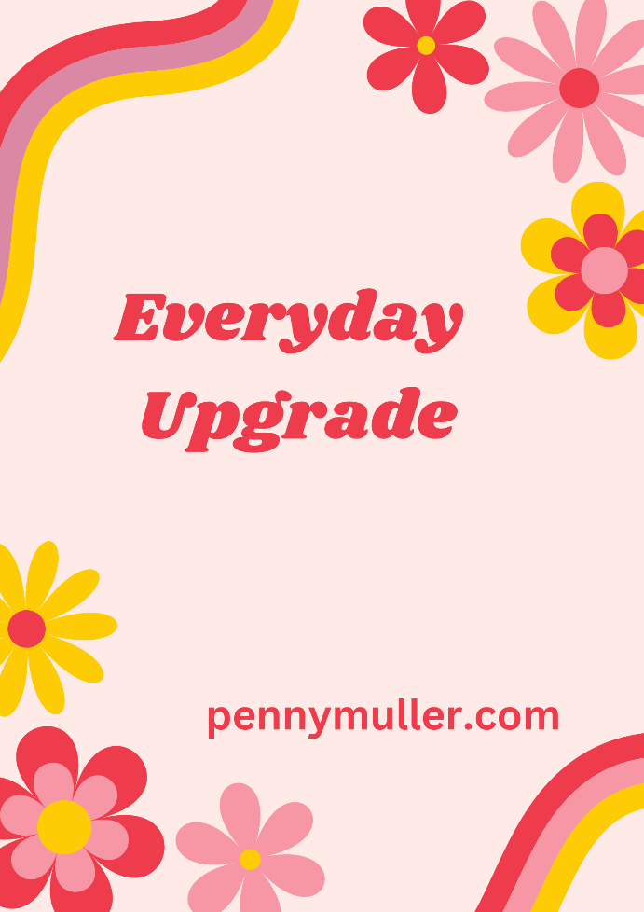For the Mind

Begin the day by visualising aspects of your ideal life. Read inspirational material such as spiritual or self-help books or watch or listen to motivational videos or podcasts. Throughout the day, take opportunities to learn new skills, acquire new knowledge, explore new places or activities, create in your job or hobbies, and express yourself through conversation, writing, performing, art, or your personal style.

For the Body

For optimum wellbeing, stretch and move your body in ways that you enjoy. Prepare nourishing meals. Engage in touch, whether it be hugging a friend or family member, going for a massage, or touching or massaging your own body in ways that are pleasurable. Explore your senses through listening to music, lighting candles, crafting, or cooking. Spend some time in relaxation, particularly at the end of the day as you wind down for sleep.

For the Spirit

Laughing as much as possible during the day will lift your mood. Look for opportunities to give and be open to receiving, as an equal balance of both will nourish your soul. Harness the Law of Attraction to manifest wonderful experiences and things into your life. Remember to show appreciation, also, for those things that are manifested. Ensure that you find ways to love yourself, others, your life, and the world around you.

New habits start with intentionality. If you are feeling down, use this list to track the positive steps you are taking each day to upgrade your reality. Alternatively, use the blank checklist to create a personalised list of aspects that are healing, nurturing, and uplifting for you.

**Everyday Upgrade Daily Checklist**

|  |  |  |  |  |  |  |  |
| --- | --- | --- | --- | --- | --- | --- | --- |
|  | **M** | **T** | **W** | **Th** | **F** | **St** | **Sn** |
| **Mind** |  |  |  |  |  |  |  |
| Visualise |  |  |  |  |  |  |  |
| Be Inspired |  |  |  |  |  |  |  |
| Learn |  |  |  |  |  |  |  |
| Explore |  |  |  |  |  |  |  |
| Create |  |  |  |  |  |  |  |
| Express |  |  |  |  |  |  |  |
| **Body** |  |  |  |  |  |  |  |
| Stretch |  |  |  |  |  |  |  |
| Move |  |  |  |  |  |  |  |
| Nourish |  |  |  |  |  |  |  |
| Touch |  |  |  |  |  |  |  |
| Senses |  |  |  |  |  |  |  |
| Relax |  |  |  |  |  |  |  |
| **Spirit** |  |  |  |  |  |  |  |
| Laugh |  |  |  |  |  |  |  |
| Give |  |  |  |  |  |  |  |
| Receive |  |  |  |  |  |  |  |
| Attract |  |  |  |  |  |  |  |
| Thank |  |  |  |  |  |  |  |
| Love |  |  |  |  |  |  |  |

**Everyday Upgrade Daily Checklist**

|  |  |  |  |  |  |  |  |
| --- | --- | --- | --- | --- | --- | --- | --- |
|  | **M** | **T** | **W** | **Th** | **F** | **St** | **Sn** |
| **Mind** |  |  |  |  |  |  |  |
|  |  |  |  |  |  |  |  |
|  |  |  |  |  |  |  |  |
|  |  |  |  |  |  |  |  |
|  |  |  |  |  |  |  |  |
|  |  |  |  |  |  |  |  |
|  |  |  |  |  |  |  |  |
| **Body** |  |  |  |  |  |  |  |
|  |  |  |  |  |  |  |  |
|  |  |  |  |  |  |  |  |
|  |  |  |  |  |  |  |  |
|  |  |  |  |  |  |  |  |
|  |  |  |  |  |  |  |  |
|  |  |  |  |  |  |  |  |
|  |  |  |  |  |  |  |  |
| **Spirit** |  |  |  |  |  |  |  |
|  |  |  |  |  |  |  |  |
|  |  |  |  |  |  |  |  |
|  |  |  |  |  |  |  |  |
|  |  |  |  |  |  |  |  |
|  |  |  |  |  |  |  |  |
|  |  |  |  |  |  |  |  |

**Thank You Universe!**

**Dear Universe,**

This has been the most incredible year. I would like to thank you for everything that has happened in my life. ---------------------------------------------------------------------------------------------------------------------------------------------------------------------------------------------------------------------------------------------------------------------------------------------------------------------------------------------------------------------------------------------------------------------------------------------------------------------------------------------------------------------------------------------------------------

With Kindest Regards,

--------------------------------------------

**Ideal Life Journaling**

I wake up in the morning in the place I love most: -----------------------------------------------------------------------------------------------------------------------------------.

I live alone / with --------------------------------------.

I look around my house / unit / property / --------------, and I see many things I love: -----------------------------------------------------------------------------------------------------------------------------------------------------------------------------------------.

The first things I do in the morning are -------------------------------------------------------------------------------------------------------------------------------------------------------------------------------------------------------------------------------------------------.

I enjoy doing purposeful activities, which include -----------------------------------------------------------------------------------------------------------------------------------------------------------------------------------------------------------------------, and I am compensated generously for my contributions.

I have ample leisure time, and I love to spend it doing ------------------------------------------------------------------------------------------------------------------------------------------------------------------------------------------------------------------------------------------------------------------------------------------------------------------------------.

I spend time with people who share my values and interests, and when we catch up with each other, we --------------------------------------------------------------------------------------------------------------------------------------------------------------------------------------------------------------------------------------------------------------------.

I am in excellent health, have lots of energy and motivation, and enjoy making plans for the future. Many of my dreams and plans have already come true, including ------------------------------------------------------------------------------------------------------------------------------------------------------------------------------------------------------------------------------------------------------------------------------------------------------------------------------------------------------------------------------------.